
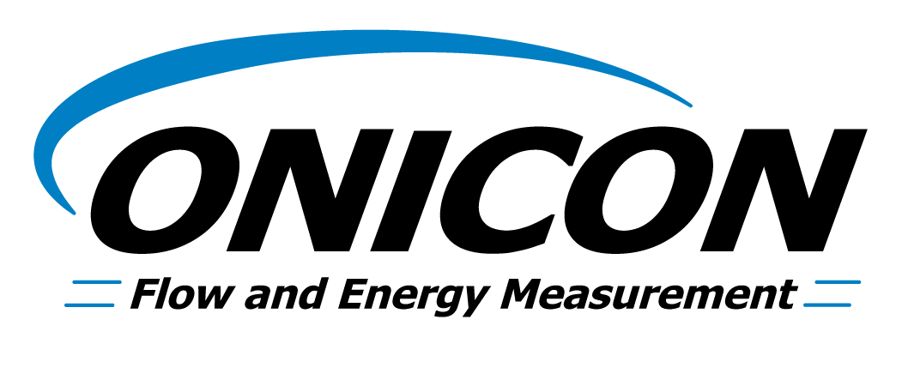
Energy (Btu) Measurement System Specification

For Commercial Tenant Sub-Metering Applications

(Chilled Water & Heating Hot Water) AUG 2013

Energy (Btu) Sub-Metering System Specification

The entire Energy Measurement System shall be built and calibrated by a single manufacturer, ONICON Incorporated, and shall consist of a flow meter, two temperature sensors, a Btu meter, temperature thermowells, and all required mechanical installation hardware. A certificate of NIST* traceable calibration shall be provided with each system. All equipment shall be covered by the manufacturer’s two year warranty.

Btu Meter: Provide an ONICON System-10 BTU Meter. The Btu meter shall provide the following information via both an integral LCD, and via serial network communications (protocol conforming to BACnet MS/TP, BACnet/IP, LONWORKS®, JCI-N2, MODBUS RTU RS485, MODBUS RTU TCP/IP or Siemens-P1): Energy Total, Energy Rate, Flow Total, Flow Rate, Supply Temperature and Return Temperature. Each Btu meter shall be factory programmed for its specific application, and shall be re-programmable using the front panel keypad (no special interface device or computer required).

NOTE TO ENGINEER:
For projects where a compatible serial communication network is not present, a dry-contact pulse output corresponding to Energy Total shall be provided for connection to the building control system. In addition, you may specify up to four additional (optional) analog outputs (4-20mA, 0-10V or 0-5V) for flow rate, energy rate, supply temperature and return temperature.

Flow Meter: Provide an ONICON Turbine Flow Meter. Insertion type flow meters shall be provided complete with all installation hardware necessary to enable insertion and removal of the meter without system shutdown, and be hand-insertable up to 400 psi. Inline meters shall be installed with isolation valves to allow installation or removal of the flow meter without a system shutdown. Turbine rotation shall be detected by electronic impedance-based sensing (non-magnetic). Each flow meter shall be individually wet-calibrated against a primary volumetric standard that is accurate to within 0.1% and traceable to NIST*. A certificate of calibration shall be provided with each flow meter. Accuracy shall be within ± 0.5% of rate at the calibrated velocity, within ± 1% of rate over a 10:1 turndown (3.0 to 30 ft/s) and within ± 2% of rate over a 50:1 turndown (from 0.4 to 20 ft/s). The flow meter shall include an integral 0-15V square wave output as an input to the ONICON Btu Meter.

Model to be selected as follows:

Model F-1300 Inline Turbine Flow Meter for line sizes ¾” or 1” (flow rate up to 38 gpm)

Model F-1100 Single Turbine Insertion Flow Meter for line sizes 1 ¼” and larger with 30 diameters of straight run pipe available for installation.

Model F-1200 Dual Turbine Insertion Flow Meter for line sizes 2 ½” and larger with less than 30 diameters of straight run pipe available for installation.

Temperature sensors: Temperature sensors shall be loop-powered current based (mA) sensors and shall be bath-calibrated and matched (NIST* traceable) for the specific temperature range for each application. The calculated differential temperature used in the energy calculation shall be accurate to within +0.15⁰F (including the error from individual temperature sensors, sensor matching, input offsets, and calculations).

* U.S. National Institute of Standards and Technology

